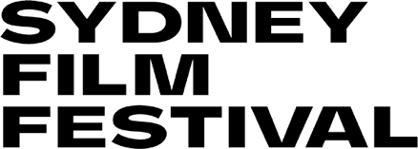

Sydney Film Festival Disability and Inclusion Action Plan (DIAP)
Progress Report: February 2020
The DIAP is an ongoing priority for Sydney Film Festival (SFF). Since it was launched in May 2019, the SFF Senior Management Team has met bi-annually to discuss progress and identify areas where improvement is needed.
The Festival has achieved the following actions to date:
- Established an external disability and inclusion advisory panel, comprised of people with a range of disabilities, to help SFF improve its accessibility across all areas of operation.
- Worked with the panel to create a venue access checklist and conduct regular venue audits, to encourage its partner venues to become more accessible.
- Through its website and the printed Festival program guide; promoted access services and ensured a range of clear booking options are available for audiences with disability.
- Offered the public a range of ways to communicate with the Festival and its staff.
- Ensured video materials produced and shared by SFF have captions.
- Included promotion of Screenability, and information about access in general at SFF in the annual marketing plan.
- Continued to build on the strong branding of Screenability to highlight disability-led storytelling.
- Employed a Screenability programmer with lived experience of disability.
- Held a public panel discussion during SFF 2019 that featured film industry professionals with a disability who discussed their work and promoted authentic casting.
- Worked closely with Create NSW on their delivery of various initiatives for filmmakers with disability.
- Incorporated acknowledgement of SFF’s DIAP and its work towards a more accessible and inclusive workplace in new employee induction.
- Worked with Accessible Arts to provide training for all SFF staff and provision of an access “cheat sheet’ for all staff.
- Shared knowledge and learnings gained from producing the DIAP and implementing it across all aspects of the Festival’s operations, at Arts Activated - a conference with a focus on disability in the arts sector.
The next review will take place in August 2020.

